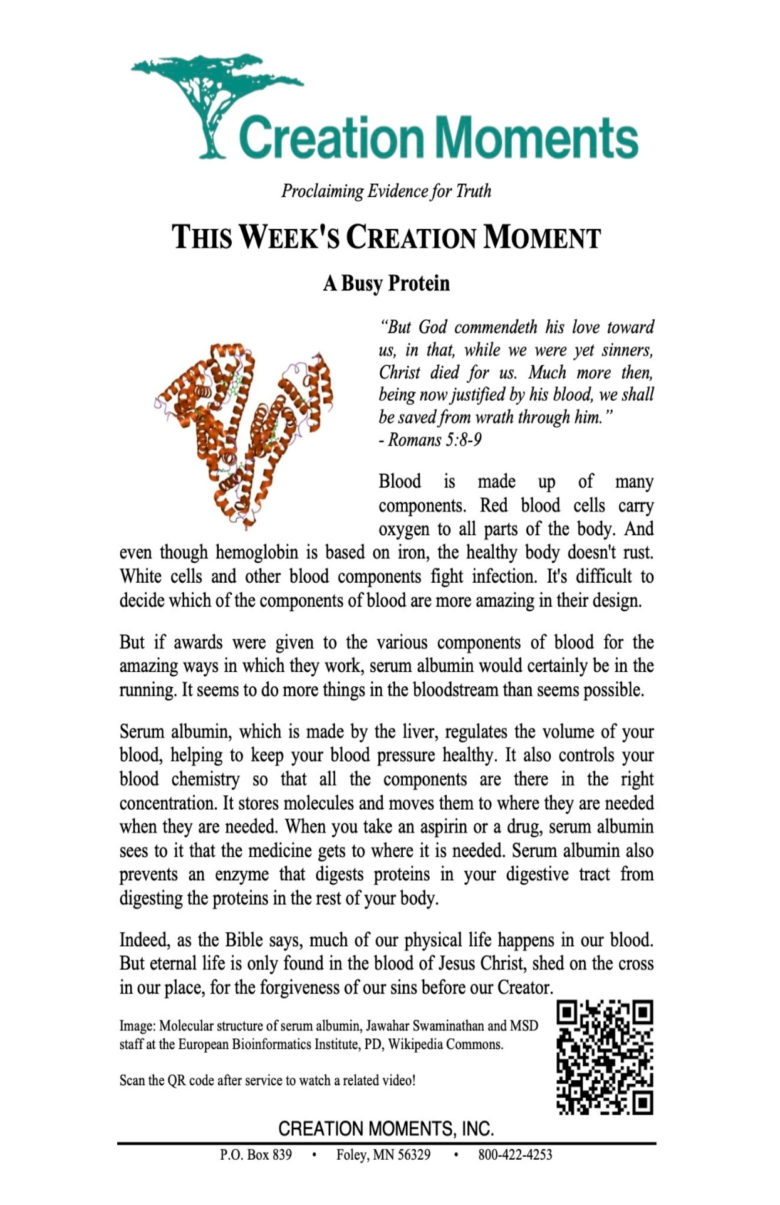
Memorial Baptist Church

April 5, 2026

Church Office
Office Hours: Mon. – Thurs. 8-2
(573) 237-2154
Memorial@mbcnewhaven.com

Visit our website at: www.mbcnewhaven.com

Pastor, Daniel Cargill (501) 607-0701
Secretary, Linda Warner (314) 795-7832
Music Coordinator, Jeff Krueger (314) 971-4243
Deacon on Call: Bob Gerling (636) 358-3071

Thank you for joining us for worship today. If you are a guest with us today, or have any prayer needs, please fill out the MBC Connect Card that is in your bulletin and place it in the offering plate.

March 29, 2026

Sunday School 68
Sunday AM Worship 154



Weekly Budget
Needed weekly $5,919.37
Received $8,711.50
Over (Under) $2.792.13
YTD Over (Under) $(2,735.78)
Annie Armstrong $195.00

Sunday AM Worship

Weekly Budget
Needed weekly $5,919.37
Received $
Over (Under) $
YTD Over (Under) $(5,527.91)
Annie Armstrong $

This Week at Memorial

Sunday April 5, 2026

9:00AM - Breakfast
10:00AM – Worship
Easter Egg Hunt (following worship)

Look Ahead
4/26 – John Morris from GAP will be speaking.

Youth Camp Information
Summer Youth Camp- June 15-21. Cost $130.
Camp registration forms and information is available now. See Chris Smith for details.

Annie Armstrong Offering
$882 has been donated to the Annie Armstrong Offering. Thank you for your giving.


Easter Grass Needed
Easter grass is needed for VBS
Please leave any donations
in the church office.

April 5, 2025
Joy Junction
8:45AM – No Sunday School
10:00AM Svc: Christine G - Kim S
Wed, April 8: Cindy S
Junior Church
NO JUNIOR CHURCH

The Way – Wed – April 8
6PM – 7:55PM In the FL
Usher Ministry
9:00am - Breakfast - Curtis C
10:00am – Jim S - James P
Wed, April 8 – Ryan W

c

c

c

c

c
c

c
c

c

Wed. – October 12 – Steve G.

Mar. 15 – Mission Committee Mtg.
Mar. 17 – Youth Open Gym

April 12, 2025
Joy Junction
8:45AM – Barb G
10:00AM Svc: Bekah H – Jamie B
Wed, April 15: Linda W
Junior Church
Mike Cook – Zachariah C

The Way – Wed – April 15
6PM – 7:55PM In the FL
Usher Ministry
8:45 - Sunday School – Steve G
10:00am – Joe G – James P
Wed, April 15 – Tim R

c

GAP Family Mission Opportunity
There will be an opportunity for families to serve on a GAP mission trip from July 5 – 10. Please see Kristin Cargill for details.

